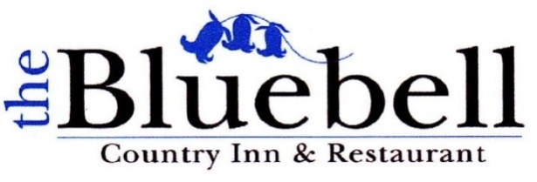

***Sunday Lunch Menu***

**Starters**

~ Homemade Leek and Potato Soup ~

~ Chicken Liver Pate with Melba Toast and Chutney ~

~ Smoked Salmon and Prawns with Marie Rose Sauce (gf) ~

~ Smoked Mackerel with Horseradish Sauce ~

**Mains**

~ Roast Sirloin of Beef ~

~ Roast Leg of Lamb ~

~ Roast Loin of Pork with Apricot Stuffing ~

~ Salmon Fillet with White Wine, Cream and Prawn Sauce ~

~ Chicken Fillet with Cream, Mushroom and Black Pepper Sauce ~

~ Beetroot and Butternut squash Wellington with Vegetable Gravy (vg) ~

**Desserts**

~ Sticky Toffee Pudding ~

~ Apple Pie with Custard ~

~ Bakewell Tart ~

~ Tiramisu ~

~ Sticky Lemon and Ginger Cake ~

~ Selection of Ice Creams and Sorbets ~

*2 Courses £25.95 3 Courses £29.95*

*Kids under 12*

*2 Courses £19.95 3 Courses £24.95*

B

